- 4 types of sentences

- Interrogative
  - ?
  - asks a question

- Imperative
  - (.) (!)
  - gives a command/makes a request
  - “please”--request

- declarative
  - (.)
  - makes a statement

- exclamatory
  - !
  - expresses strong emotion or feeling

- Fragments:
- A sentence must have two characteristics:
- 1. It must have a subject and a verb;
2. it must have independence or completeness

- Ex. Sylvia feels happy this morning. Because the sun is shining. She is leaving early to take a walk in the woods.

- Run-ons:
  - A sentences that just keeps on going.
  - It needs you to put the “breaks” on. (punctuation)
  - If you feel like you need to take a breath in the middle of reading it, it’s probably too long!!!!

- Ex. The reason we drove to the lake was to go fishing we ended up swimming all day

- Sentence Structure:
  - Simple
  - Compound
  - Complex
  - Compound-complex
- Example:
- Mary / plays tennis.

- Simple Sentence-
  - has 1 subject and 1 predicate.
  - Example:
    - We/went to San Juan yesterday.

  - Compound Sentence:
    - Def
    - Example:
      - We went to San Juan, and we danced all night.
      - We went to San Juan. ---sentence #1
      - Structure of the sentences---

(subject) (predicate) ,conjuction (subject)(predicate)
      - We danced all night.---sentence #2
      - Joined with---(a ‘connector’)
        - , and
        - ,yet
        - ,for
        - , but
        - , or
        - , so
        - ; however,
        - ; therefore,
        - ; moreover,
        - ; otherwise,

    - Complex Sentences
      - Def: has at least 2 parts; one sentences that can stand alone and one that cannot
      - Example: Since my boyfriend and I wanted to have fun, we went to San Juan yesterday.
      - Often the sentences begins with Since—if---While---so—unless—although---because—when

Dependent Clause—
    - NOT a complete sentence
    - Can’t stand alone
    - “must have help to make sense”

Independent Clause-
    - a Complete sentence
    - it doesn’t need the other part to exist and make sense
    - CAN stand alone

  - Example:
    - If we have a snow day tomorrow, we will get to stay home.

Dependent Independent

- Simple: Mary and Tom went to San Juan yesterday.
- Compound: Mary and Tom went to San Juan yesterday, and they had fun.
- Complex: While Mary and Tom went to San Juan yesterday to have fun, they
- were bored.

- .
- There are 2 parts to every sentences: A subject and a predicate….
- Subject-
  - who or what the sentences is about
- Predicate-
  - tells something about the subject
  - tells what the subject is doing(action)
- Steps for finding each:
  - 1st—ask yourself who or what the sentence is about(that’s your subject!!!!)
  - 2nd-everything after the subject is the predicate
    - YES THAT MEANS EVERY LITTLE WORD

- Simple Subjects and Predicates

- simple- a single sentence that expresses one thought

- compound sentence-
  - 2 related sentences joined together to express one thought or idea
  - joined with a comma (,) and connecting word(and,but,or)

- Perfect Tense indicates the COMPLETION of an action(it already happened or will have already happened by a certain time)

- 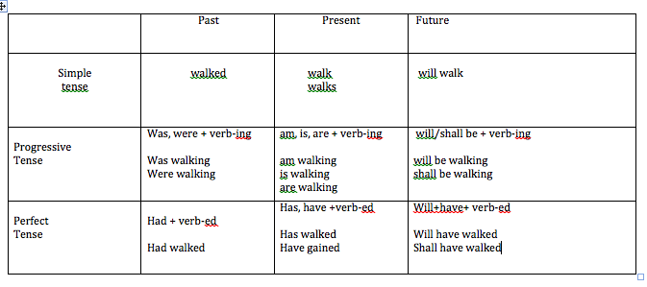

- 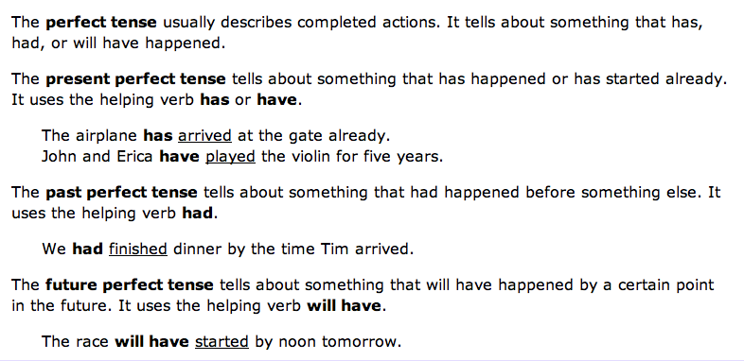
- Adjectives modify nouns.
  - They “describe” nouns.
    - What kind
    - How many

  - Tells more about that noun.

    - Brown(noun)
    - Beach(noun)
    - Huge(noun)
    - Green, fat(noun)
    - Tall, skinny(noun)
    - Confederate(noun)

